Lab 7 – My Solutions
3.1: Screenshots for every user:
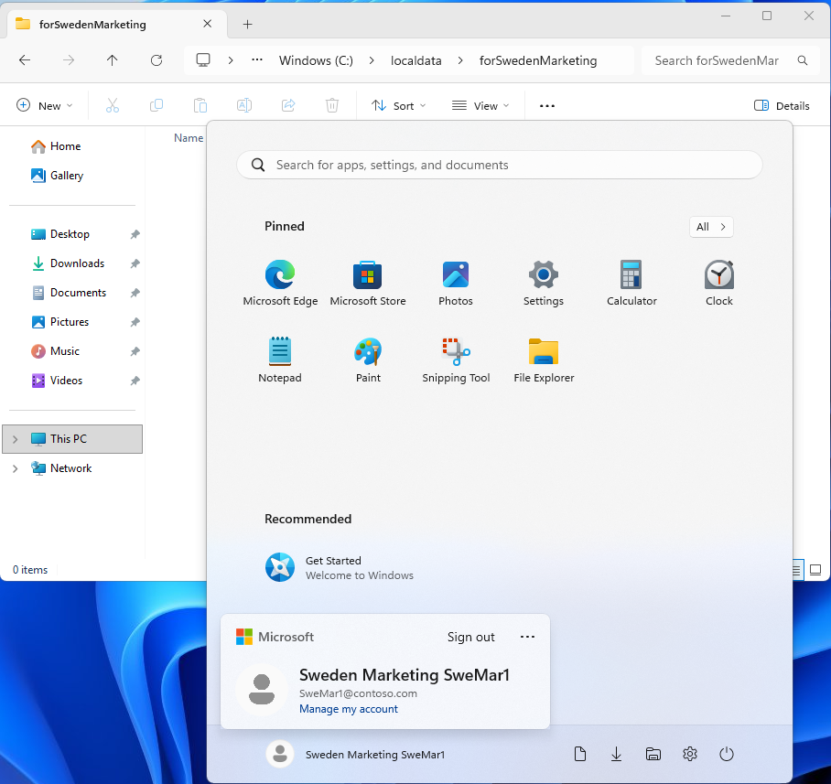
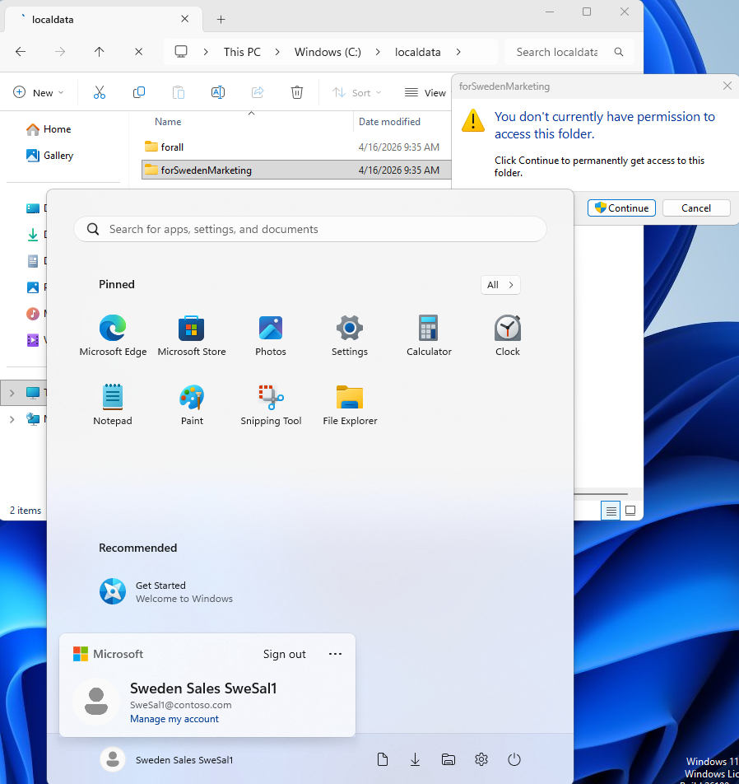
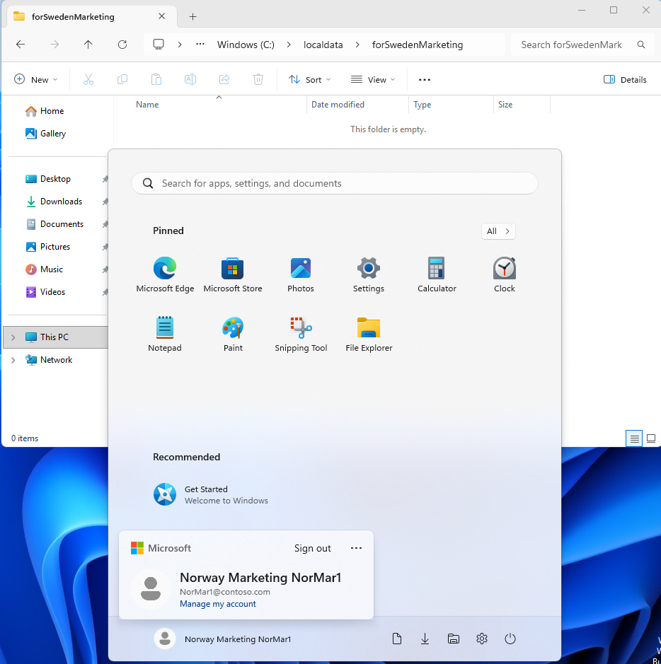

3.2: Simple Folder Sharing:
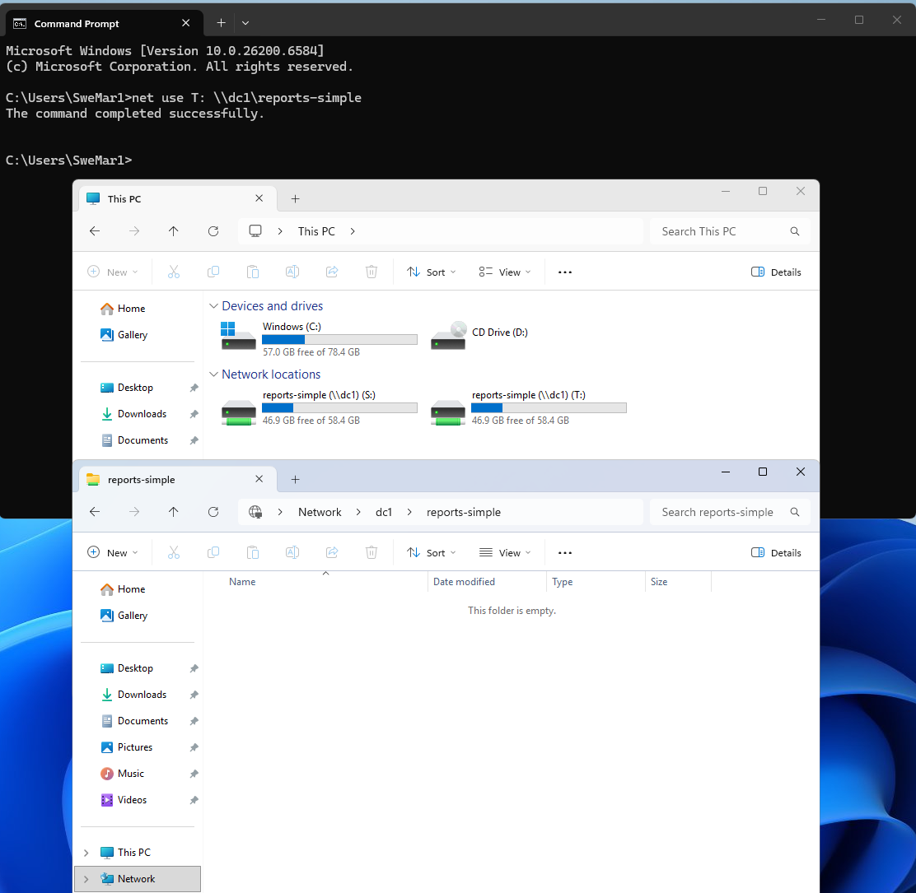

3.3: Advanced Folder Sharing
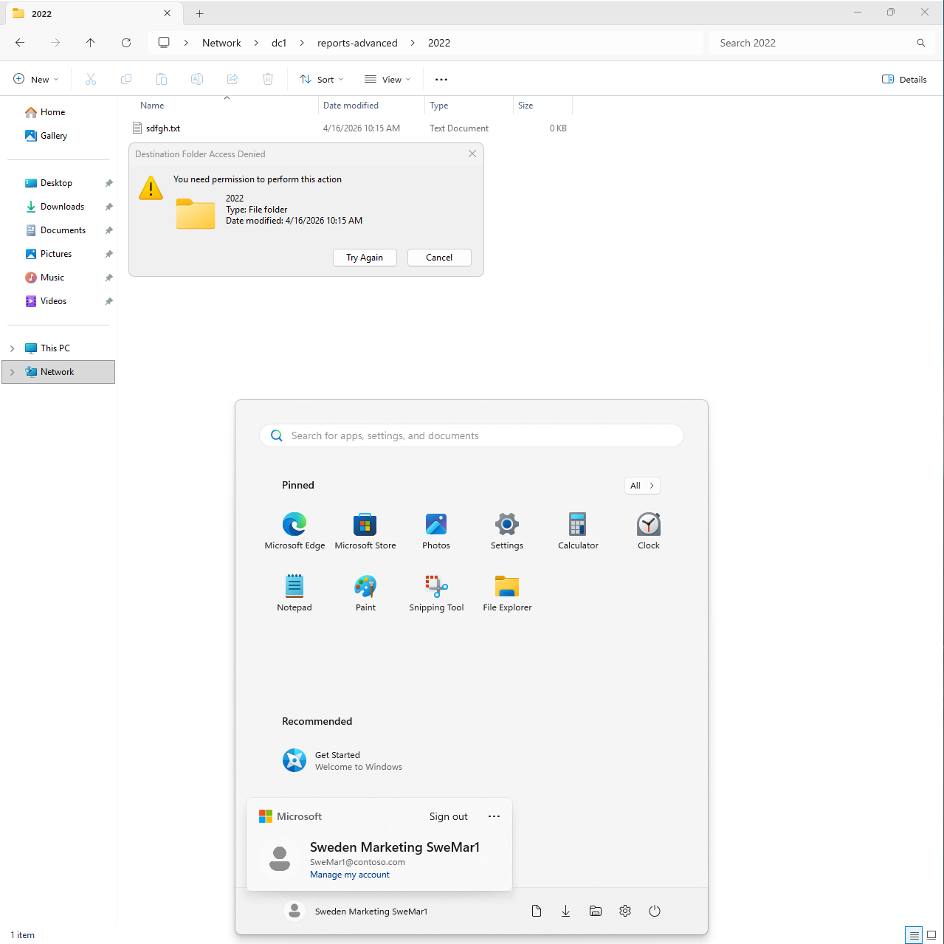
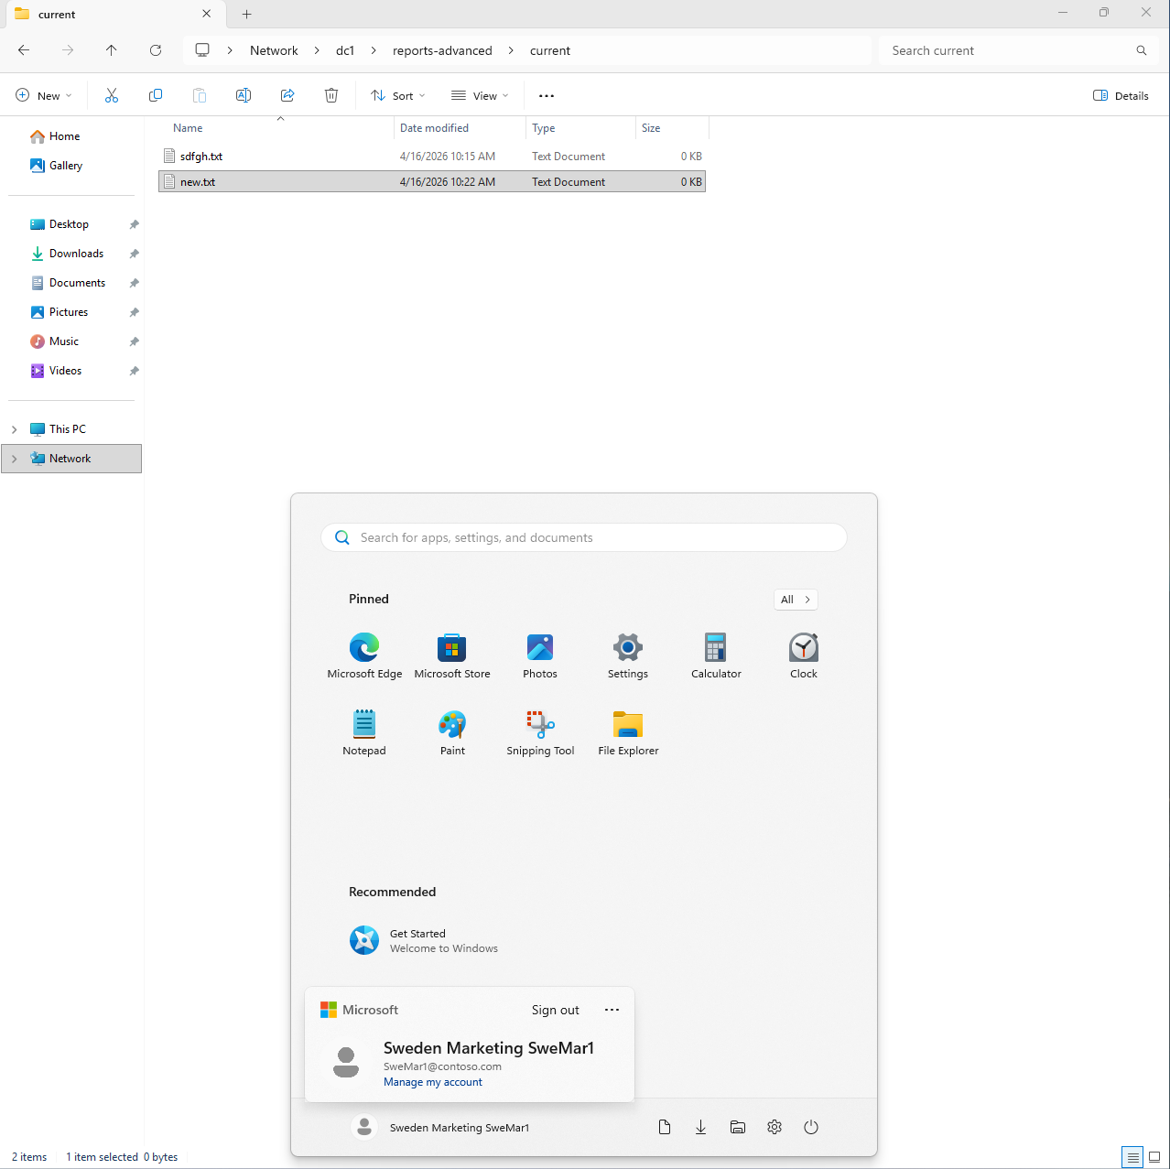

3.4: Sharing Folders via PowerShell
> New-Item C:\reports-ps -Type Directory
> New-SMBShare -Name "reports-powershell" -Path c:\reports-ps -FullAccess "G_Sweden_Marketing" -ReadAccess "U_Marketing"
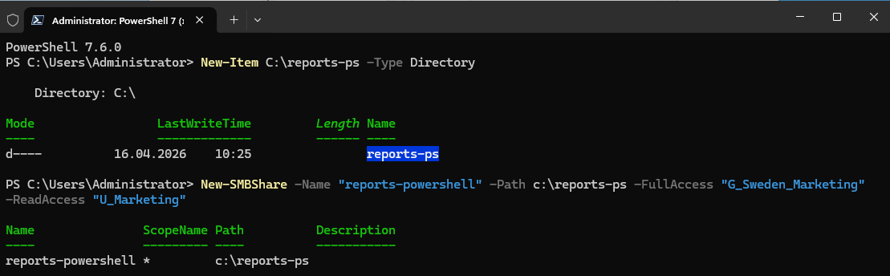
New-PSDrive -Name R -PSProvider FileSystem -Root "\\dc1\reports-powershell" -Persist
